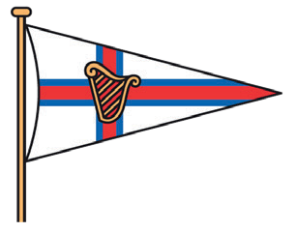
PENARTH
Y A C H T C L U B
EST. 1880

Membership Application
(Please print clearly)
Title: First Name: Surname:

Address:

Postcode:

Contact Numbers - Home: Mobile:

Email Address:

Membership Category:
(For family membership - one application per person)

Date of Birth: | / | / | Date of Application: ……………
Interested in : Occupation (Optional) |  |  | Sailing | | | Rowing | General
How did you hear about the Yacht Club?

Names & Date of Births
for Children using
Family membership -

NOTES:
Children can be accompanied by family members up to their 18th Birthday.
Children under 18yrs that sail and/or row are requested to become junior members.
The information provided will not be passed on to any third party or used in any marketing scheme.
Once completed, please return this form to the Club Secretary by post or email: secretary@penarthyachtclub.co.uk

The Esplanade, Penarth, Vale of Glamorgan, CF64 3AU Tel: 029 2070 9233 www.penarthyachtclub.com

